# Setup Guide

# For Datamax-O’Neil Android SDK

# And Android Applications in Eclipse

# November 20, 2013

## Requirements

1. Latest Android SDK installed
2. Eclipse Installed
3. Android ADT Plugin for Eclipse

## Setting up Eclipse

Please see the following link for instructions on how to setup Eclipse for Android SDK:

<http://developer.android.com/sdk/index.html>

## Integrating D-O Android SDK into Android Applications

1. Click **File-> New -> Android Application Project.**

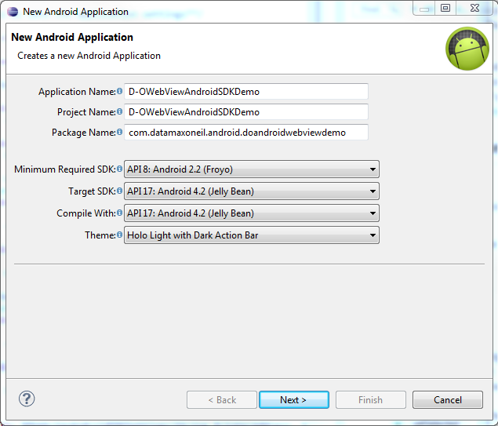

1. Navigate to the project’s directory and open the **libs** folder.

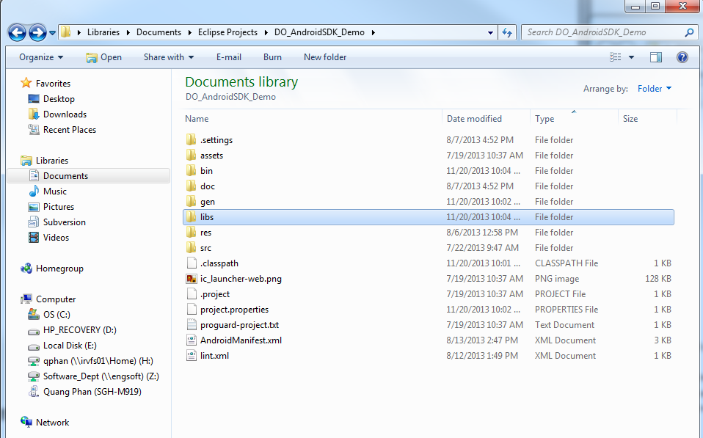

1. Copy **do_androidsdk.jar** into the libs folder Eclipse should automatically add the library to your project. You should be able to compile and run Android applications with D-O Android SDK.

